LAB MANUAL
PART B

Roll No. C-60 | Name: Avdhut Madhavi
Class: C | Batch: C2
Date of Experiment: | Date of Submission:
Grade:

B.1: Implement and trace the following programs. Write the code, compile/run it, and record the output after each task.
- Write a C program to implement Selection Sort on an array of integers entered by the user, and display the array after every pass.

#include <stdio.h>
#include <conio.h>
int main() {
int a[100], n, i, j, min, temp;

printf("Enter number of elements: ");
scanf("%d", &n);

printf("Enter array elements: ");
for (i = 0; i < n; i++) {
scanf("%d", &a[i]);
}

for (i = 0; i < n - 1; i++) {
min = i;

for (j = i + 1; j < n; j++) {
if (a[j] < a[min]) {
min = j;
}
}

temp = a[i];
a[i] = a[min];
a[min] = temp;

printf("Pass %d: ", i + 1);
for (j = 0; j < n; j++) {
printf("%d ", a[j]);
}
printf("\n");
}

printf("Sorted array: ");
for (i = 0; i < n; i++) {
printf("%d ", a[i]);
}
getch();
return 0;
}

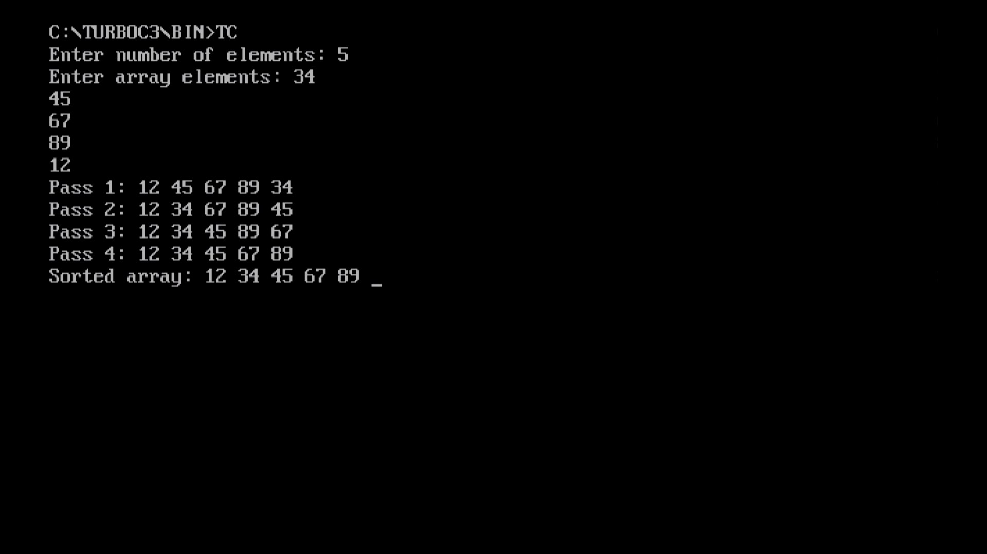

- Modify the Selection Sort program to count and display the total number of comparisons and swaps performed.

#include <stdio.h>
#include <conio.h>
int main() {
int a[100], n, i, j, min, temp;
int comparisons = 0, swaps = 0;

printf("Enter number of elements: ");
scanf("%d", &n);

printf("Enter array elements: ");
for (i = 0; i < n; i++) {
scanf("%d", &a[i]);
}

for (i = 0; i < n - 1; i++) {
min = i;

for (j = i + 1; j < n; j++) {
comparisons++;

if (a[j] < a[min]) {
min = j;
}
}

if (min != i) {
temp = a[i];
a[i] = a[min];
a[min] = temp;
swaps++;
}

printf("Pass %d: ", i + 1);
for (j = 0; j < n; j++) {
printf("%d ", a[j]);
}
printf("\n");
}

printf("Sorted array: ");
for (i = 0; i < n; i++) {
printf("%d ", a[i]);
}

printf("\nTotal comparisons: %d", comparisons);
printf("\nTotal swaps: %d\n", swaps);
getch();
return 0;
}

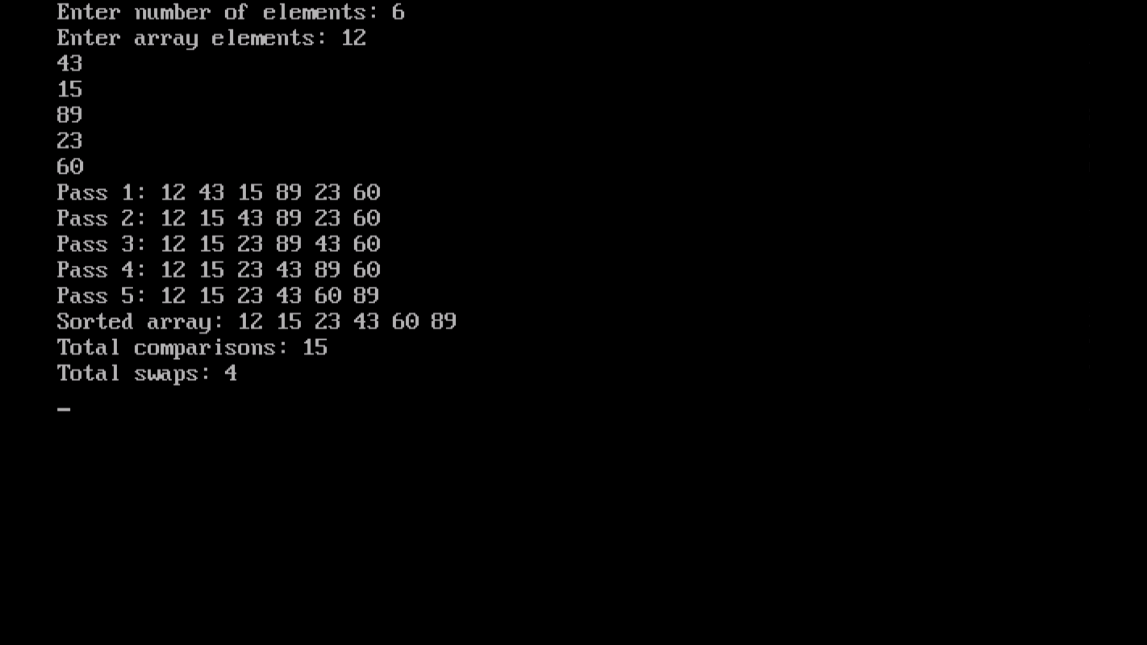

- Run both programs on the same already-sorted array (e.g., 1, 2, 3, 4, 5) and compare the number of operations each algorithm performs.
Input array:
1 2 3 4 5
Selection Sort still searches the entire unsorted portion on every pass, even when the array is already sorted.
The number of comparisons is:
$$\frac{n\left(n-1\right)}{2}=\frac{5\left(5-1\right)}{2}=10$$

Since the smallest element is already at the beginning of each pass, no actual swaps are needed.
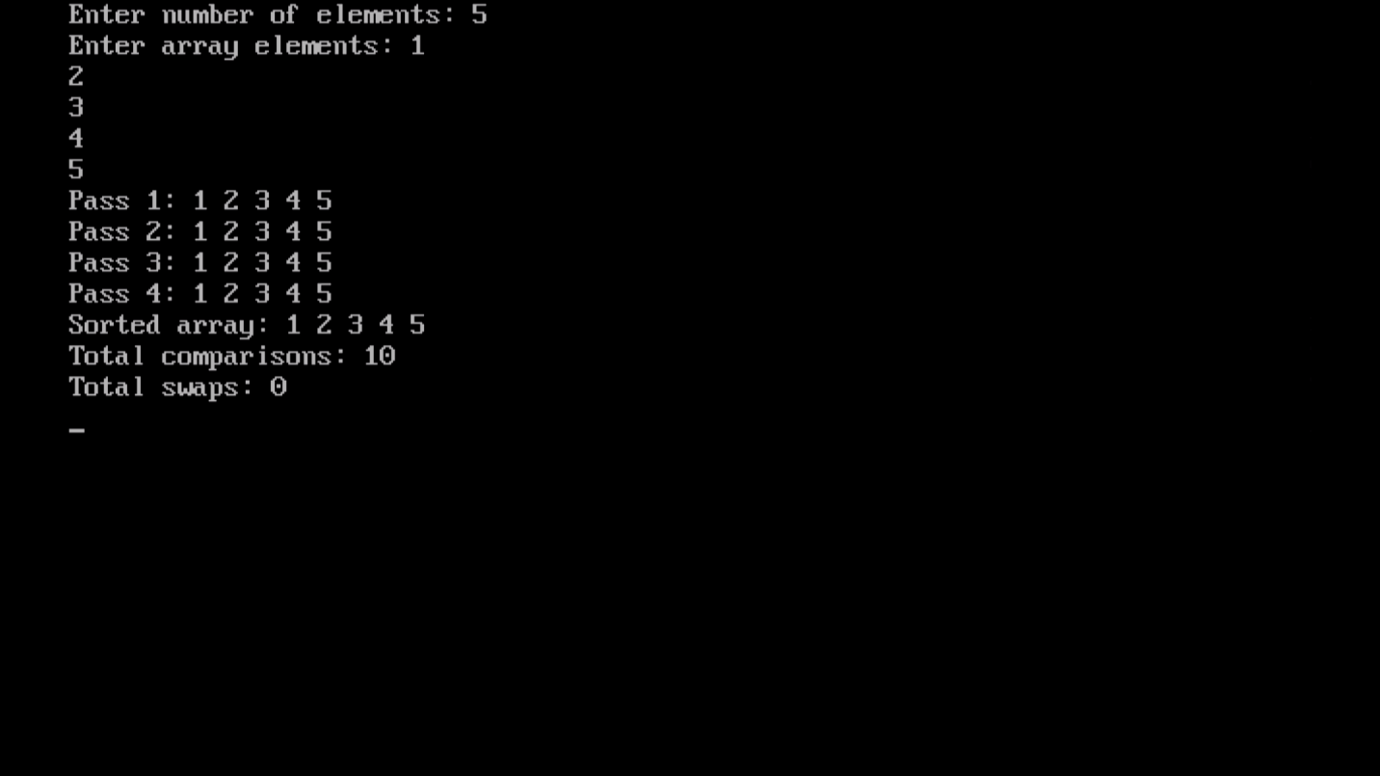
Conclusion: Both programs perform the same sorting operations. Program 2 additionally counts and displays the operations, making it useful for analyzing algorithm performance.

- Trace Selection Sort and Insertion Sort by hand on the array [8, 3, 5, 1, 9, 2], showing the array state after each pass.

Input array: [8, 3, 5, 1, 9, 2]
Pass 1: Find the smallest element, 1, and swap it with 8.
Array: [1, 3, 5, 8, 9, 2]
Pass 2: Find the smallest element in the remaining unsorted part, 2, and swap it with 3.
Array: [1, 2, 5, 8, 9, 3]
Pass 3: Find the smallest element, 3, and swap it with 5.
Array: [1, 2, 3, 8, 9, 5]
Pass 4: Find the smallest element, 5, and swap it with 8.
Array: [1, 2, 3, 5, 9, 8]
Pass 5: Find the smallest element, 8, and swap it with 9.
Array: [1, 2, 3, 5, 8, 9]
Final sorted array: [1, 2, 3, 5, 8, 9]

5. Hand Trace of Insertion Sort
Input array: [8, 3, 5, 1, 9, 2]
Pass 1: Take 3 as the key and insert it before 8.
Array: [3, 8, 5, 1, 9, 2]
Pass 2: Take 5 as the key and insert it between 3 and 8.
Array: [3, 5, 8, 1, 9, 2]
Pass 3: Take 1 as the key and insert it at the beginning.
Array: [1, 3, 5, 8, 9, 2]
Pass 4: Take 9 as the key. It is already in the correct position.
Array: [1, 3, 5, 8, 9, 2]
Pass 5: Take 2 as the key and insert it after 1.
Array: [1, 2, 3, 5, 8, 9]
Final sorted array: [1, 2, 3, 5, 8, 9]

6. Time and Space Complexity
Algorithm | Best Case | Average Case | Worst Case | Space
Selection Sort | O(n²) | O(n²) | O(n²) | O(1)
Insertion Sort | O(n) | O(n²) | O(n²) | O(1)

Conclusion: Selection Sort always performs O(n²) comparisons. Insertion Sort is more efficient for already-sorted or nearly sorted arrays because its best-case time complexity is O(n).

B.2: Write an observation according to the program execution.
- Selection Sort sorts the array in ascending order by repeatedly finding the minimum element.
- Insertion Sort sorts the array by inserting each element into its correct position.
- Selection Sort performs $O\left(n^{2}\right)$ comparisons, while Insertion Sort has a best-case time complexity of O(n).
- Both algorithms successfully sort the given array.

